**HTML and CSS**

Table of Contents:

1. Introduction………………………………………………………………………………….2

2. What is HTML ……………………………………………………………………………….2

3. What is CSS ………………………………………………………………………………….2

4. Roles of Web Technology …………………………………………………………….2

5. What can HTML and CSS do …………………………………………………………2

6. Basic Syntax of HTML is made of Tags, Attributes & Elements………3

7. Doctype and Basic layout of modern HTML ………………………………….3

8. Setting up live server ………………………………………………………………...….4

9.Headings, Paragraphs & Topography models…………………………………5

10. Links, Images & attributes of modern HTML ……………………………….6

11. Forms & Input modern HTML & CSS ……………………………………………7

12. Divs, Spans, Classes & ids ……………………………………………………………9

13. Creating a comment ………………………………………………………………….11

14. Meta tags ………………………………………………………………………………….11

15.HTML Block and Inline Elements ………………………………………………….12

15.1 Some block level elements……………………………………….12

15.2 HTML Inline Elements ………………………………………………13

16.HTML Divs & Span, Classes & ID’s ……………………………………………….13

17. HTML Entities ……………………………………………………………………………13

18. HTML Tags ……………………………………………………………………………….14

18.1 Some Most used Tags in HTML Code……………………….14

19. Creating project named HOTEL WEBSITE ………………………………….15

20. Style.css ……………………………………………………………………………………16

21. Index.HTML …………………………………………………………………………….21

22. About.HTML ……………………………………………………………………………23

23. Contact.HTML ……………………………………………………………………….25

24. Outputs …………………………………………………………………………………27

**Modern HTML and CSS**

1. **Introduction: -**

* HTML & CSS is a comprehensive course and the latest features are FLEX, GRID, ANIMATION, VARIABLES, etc.,
* It includes sections(sandbox)

1. **What is HTML?**

* HTML stands for Hyper Text Markup language.
* HTML is not a programming language.
* Markup for creating webpages/documents.
* HTML is extremely important and relevant. But is also just the beginning.

1. **What is CSS?**

* CSS stands for Cascading Style Sheets.
* CSS is used to create documents on the web.
* It is also Styling/Stylesheet language.
* It is used for styling HTML elements.
* CSS can be extending with SASS/LESS.

1. **Roles of web technologies: -**

* HTML = Content display.
* CSS = Style and Design.
* JavaScript = Dynamic front end programming.
* PHP, Python, C#, JS = Backend programming.
* MySQL, MongoDB = Database/storage.

1. **What can HTML and CSS do?**

* We can build Static websites like Portfolios, small business sites, informational & brochure websites.
* We can build the visual part of anything like stores, social networks, etc.

1. **Basic Syntax of HTML is made of Tags, Attributes & Elements: -**

* Tags are tag names surrounded by left and right-angle brackets.
* Ex- HTML tags looks like <html> and </html>.
* First tag is called opening tag and second tag is called closing tags.
* Attributes provide extra information about an element and are always specified in the opening tag.
* Ex- Attributes <strong attribute=”value”>.
* Elements is a tag and the content that it wraps around.
* Ex- <p>this is a paragraph</p>.

1. **Doctype & Basic layout of modern HTML: -**

<!DOCTYPE html>

<html>

<head>

<title>My website</title>

</head>

<body>

<h1>My website</h1>

<p>This is my first</p>

</body>

</html>

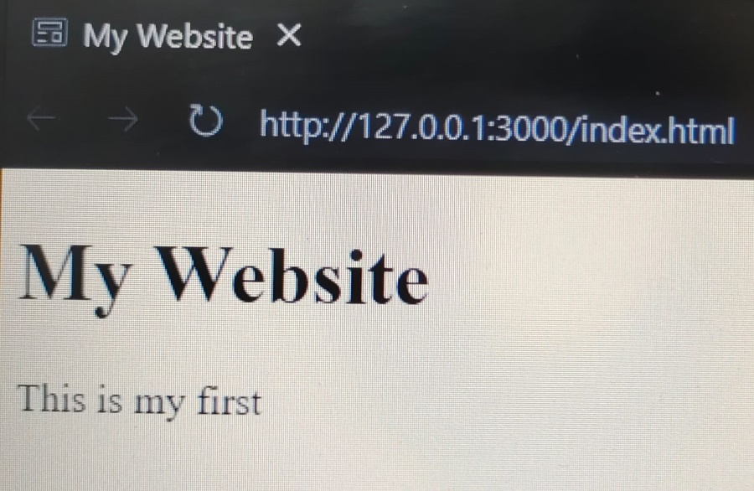

1. **Setting up live servers (vs code extension): -**

<!DOCTYPE html>

<html lang="en">

<head>

    <meta charset="UTF-8">

    <meta http-equiv="X-UA-Compatible" content="IE=edge">

    <meta name="viewport" content="width=device-width, initial-scale=1.0">

    <title>live server</title>

</head>

<body>

    <h1>Hello jessu</h1>

    <p>This is a name</p>

</body>

</html>

**Output: -**

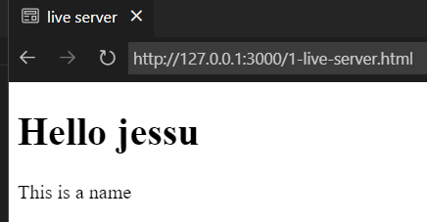

1. **Headings, Paragraphs & Topography models: -**
2. <!DOCTYPE html>
3. <html lang="en">
4. <head>
5. <meta charset="UTF-8">
6. <meta http-equiv="X-UA-Compatible" content="IE=edge">
7. <meta name="viewport" content="width=device-width, initial-scale=1.0">
8. <title>Headings, Paragraphs, Typography</title>
9. </head>
10. <body>
11. <!-- Headings  -->
12. <h1>Heading1</h1>
13. <h2>Headind2</h2>
14. <h3>Heading3</h3>
15. <h4>Heading4</h4>
16. <h5>Heading5</h5>
17. <h6>Heading6</h6>
18. <!-- Paragraphs -->
19. <p>Lorem<strong>BOLD</strong> ipsum <em>ITALIC</em> sit,<br> amet consectetur <hr> elit. <del>STRIKE OUT</del>, delectus.</p>
20. </body>
21. </html>

**Output: -**

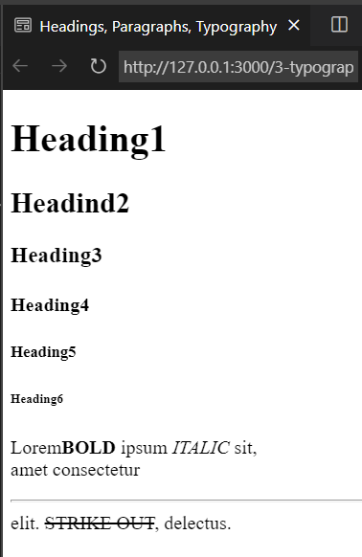

**10 Links, Images & attributes of modern HTML: -**

<!DOCTYPE html>

<html lang="en">

<head>

    <meta charset="UTF-8">

    <meta http-equiv="X-UA-Compatible" content="IE=edge">

    <meta name="viewport" content="width=device-width, initial-scale=1.0">

    <title>Links & Images</title>

</head>

<body>

    <p>

    <a href="http://google.com">Click for google</a>

    </p>

    <p>

    <a href="http://google.com"target="_blanket">Click for google</a>

    </p>

    <a href="/3-typography.html">topography</a>

    <img src="/images/Screenshot (3).png" alt="My Image" width="300">

    <img src="/images/Screenshot (4).png" alt="My Image 2"width="300">

</body>

</html>

**Output: -**

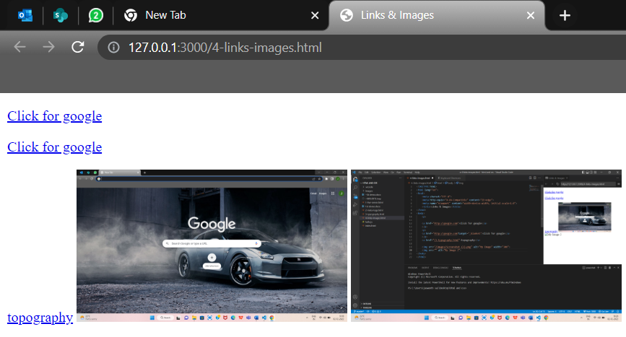

**11 Forms & Input modern HTML & CSS: -**

<!DOCTYPE html>

<html lang="en">

<head>

    <meta charset="UTF-8">

    <meta http-equiv="X-UA-Compatible" content="IE=edge">

    <meta name="viewport" content="width=device-width, initial-scale=1.0">

    <title>forms & input</title>

</head>

<body>

    <form action="process.php">

        <div>

            <label for="name">Name</label><br>

            <input type="text" id="name" name="name">

        </div>

        <div>

            <label for="Email">Email</label><br>

            <input type="email" id="email" name="email">

        </div>

        <div>

            <label for="message">message</label><br>

            <textarea name="message" id="message" name="message" cols="40"

             rows="3"></textarea>

        </div>

        <div>

            <label for="sex">sex</label>

            <select name="sex" id="sex">

                <option value="male">male</option>

                <option value="female">female</option>

                <option value="other">other</option>

            </select>

        </div>

        <div>

            <label for="age">age</label><br>

            <input type="number" name="age" id="age">

        </div>

        <div>

            <label for="birthdate">birthdate</label><br>

            <input type="date" name="birthdate" id="birthdate">

        </div>

        <div>

            <label for="membership">membership</label>

            <input type="radio" name="membership" value="simple" id="membership">simple

            <input type="radio" name="membership" value="standard" id="membership">standard

            <input type="radio" name="membership" value="super" id="membership">super

        </div>

        <!-- input tag -->

        <input type="submit" value="submit">

         <!-- button tag -->

         <!-- <button type="submit">submit</button> -->

         <input type="reset" value="reset">

    </form>

</body>

</html>

**Output: -**

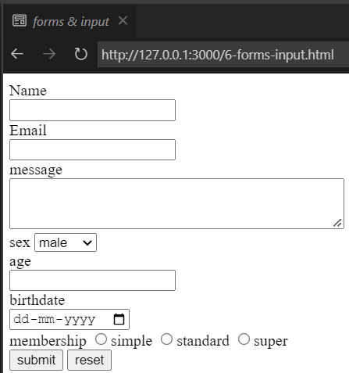

**12 Divs, Spans, Classes & ids: -**

<!DOCTYPE html>

<html lang="en">

<head>

    <meta charset="UTF-8">

    <meta http-equiv="X-UA-Compatible" content="IE=edge">

    <meta name="viewport" content="width=device-width, initial-scale=1.0">

    <title>div, span, id and class</title>

<style>

    .card {

        color: red;

        background-color:black ;

    }

</style>

</head>

<body>

    <div id="Main-Header">

        <h1>My website</h1>

        <p>A site about me</p>

    </div>

    <ul id="main-nav">

<li><a href="#">Home</a></li>

<li><a href="#">About</a></li>

<li><a href="#">Contact</a></li>

    </ul>

    <div id="about">

        <h3>About</h3>

        <p>Lorem <div class="card"> dolor sit amet consectetur adipisicing elit. A rem voluptas </div>consequuntur!</p>

    </div>

    <div id="contact">

        <h3>contact me</h3>

        <ul>

          <li>Adress: 18 Main st,kovur, nellore </li>

          <li>Email: jessu@gmail.com</li>

          <li>phone: 8767576665</li>

        </ul>

    </div>

    <div id="footer">

        <p>Copyright &copy; 2018</p>

    </div>

</body>

</html>

**Output: -**

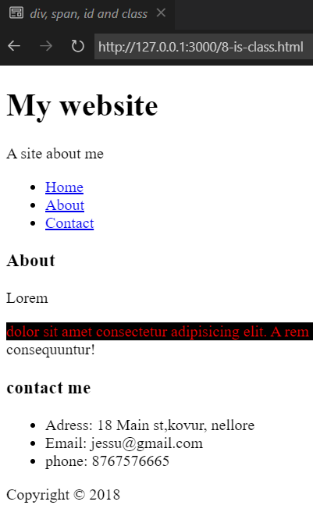

**13.Creating a Comment: -**

* <!This is My Website> This line Automatically hides the line in the Browser.

**14. Meta Tags: -**

* The Meta tags are Tags or Snippets which describe Content of the page.
* Tags have Attributes and they can be called as properties.
* The Meta Charset specifies character and coding of the page.
* UTF-8 Stands of “Unicode Transformation Format-8". UTF-8 is a variable character encoding used for electronic Communication.
* The Meta Viewport tag is used for making your website or your user interface responsive to different screen sizes.

**15. HTML Block and Inline Elements: -**

* Every HTML element has a default display value, depending on what type of element it is.
* There are Two display values: - block and inline.
* Block Level Elements- A Block level Element always starts on a new line, and the browsers automatically adds some space before and after the element.
* Two commonly used Block level elements are < p > and < div >.
* The < p > Element defines a paragraph in a HTML document.
* The < div > element defines a division or a section in an HTML document.

**15.1 Some block level elements -**

* < address>
* < canvas >
* < dt >
* < footer >
* < hr >
* < aside >
* < article>
* < di >
* < p >
* < ul >
* < li >
* < t foot >
* < table >
* < section >

**15.2 HTML Inline Elements: -**

* An Inline element does not start on a new line.
* An Inline element only takes up as much as width as necessary.
* An Inline element does not contain Block level element.
* Some of the Inline Elements in HTML are:
* < a >
* < label >
* < text area >
* < input >
* < button >
* < small >
* < span >
* < output >
* < select >

**16.HTML Divs & Span, Classes & ID’s:**

* Id Attribute: - It is used to label sections or parts of your HTML document.
* Class Attribute: - It is used to classify the parts of your document.
* Div Tag: - The DIV tag is a block level HTML Element. It is used to divide or section other HTML elements into Groups.
* Span Tag: - It is an Inline HTML element that is used to group a set of inline elements.
* The div and span has no semantic value in HTML.

**17.HTML Entities: -**

* HTML entities give variety of characters, assigning icons, mathematical operators and even geometric complex shapes.

**18. HTML tags: -**

* HTML tags are used to specify way to format and display the content of web browser.

**18.1 Some Most used Tags in HTML Code:**

* <! - -> - To apply comment.
* <!DOCTYPE> - To specify the version of HTML.
* <a> - To create a Hyperlink or Link.
* <audio> - To embed Sound content in HTML.
* <b> - To apply bold content in HTML.
* <body> - To specify the body section of a HTML content.
* <button> - To create a button.
* <div> - To specify a division or section within HTML Document.
* <footer> - To specify the footer section of the Webpage.
* <form> - To specify an HTML Form.
* <h1> to <h6> - To specify Headings in HTML Document.
* <head> - To specify head section in HTML Document.
* <header> - To specify Header Section in HTML document.
* <html> - To represent root of an HTML Document.
* <i> - To represent text in different voices.
* <input> - To specify an input field within the HTML Document.
* <img> - To insert an image within HTML Document.
* <label> - To specify label text for HTML Document.
* <li> - To represent items in List.
* <ul> - To specify unordered list of Items.
* <link> - To represent a relationship between the current document and external document.
* <main> - To represent the main content of a HTML Document.

 <meta> - To specify meta document of a HTML Document.

* <nav> - To represent section of page to represent navigation Links.
* <p> - To specify paragraph in HTML Document.
* <section> - To specify a generic section for a document.
* <span> - To style and group inline.
* <style> - To add styling to HTML Document.
* <title> - To specify name or title to HTML Document.
* <tr> - To specify the row cells in HTML Document.
* <br> - The break line tag is used to break the line of code.
* <hr> - The horizontal line tag is used to put a line across a webpage.
* <base> - To specify the base URL for all the relative URLs within the document.
* <text area> - To specify multiple line inputs, such as comments, feedback and reviews etc.

**19. Creating my own project Named HOTEL WEBSITE by using HTML and CSS:**

* First, I created a folder named HOTEL WEBSITE

**Folders:**

* Css
* Img
* Index
* About
* Contact

**20. Style.css: -**

 /* reset  */

 * {

    margin: 0;

    padding: 0;

    box-sizing: border-box;

 }

 /* main styling */

 html,body {

    font-family:'Segoe UI', Tahoma, Geneva, Verdana, sans-serif;

    line-height: 1.7em;

 }

 a {

    color: #333;

    text-decoration: none;

 }

 h1,h2,h3 {

    padding-bottom: 20px;

 }

 P {

    margin: 10px 0;

 }

 /* navbar */

 #navbar {

    background: #333;

    color: #fff;

    overflow: auto;

 }

 #navbar a {

    color: #fff;

 }

 #navbar h1 {

    float: left;

    padding-top: 20px;

 }

 #navbar ul {

    list-style: none;

    float: right;

 }

 #navbar ul li {

    float: left;

 }

 #navbar ul li a {

    display: block;

    padding: 20px;

    text-align: center;

 }

 #navbar ul li a:hover,

 #navbar ul li a.current {

    background: #444;

    color: #f7c08a;

 }

 /* utility classes */

 .container {

    margin: auto;

    max-width: 1100px;

    overflow: auto;

    padding: 0 20px;

 }

 /* showcase */

 #showcase {

    background: url('/img/pexels-donald-tong-189333.jpg') no-repeat center center/cover;

    height: 500px;

 }

 #showcase .showcase-content {

    color: #fff;

    text-align: center;

    padding-top: 100px;

 }

 #showcase .showcase-content h1 {

    font-size: 60px;

    line-height: 1.2em;

 }

 .text-primary {

    color: green;

 }

 .lead {

    font-size: 20px;

 }

 #showcase .showcase-content p {

    padding-bottom: 20px;

    line-height: 1.7em;

 }

 .btn {

    display: inline-block;

    font-size: 18px;

    color: #fff;

    background: #333;

    padding: 13px 20px;

    border: none;

    cursor: pointer;

 }

 .btn:hover {

    background: #f7c08a;

    color: #333;

 }

 .btn-light {

    background: #f4f4f4;

    color: #333;

 }

 /* home info */

 #home-info {

    height: 500px;

 }

 #home-info .info-img {

    float: left;

    width: 50%;

    background: url('../pexels-pixabay-53464.jpg') no-repeat;

    min-height: 100%;

 }

 #home-info .info-content {

    float: right;

    width: 50%;

    height: 100%;

    text-align: center;

    padding: 110px 90px;

    overflow: hidden;

 }

 .bg-dark {

    background: #333;

    color: #fff;

 }

 .bg-light {

    background: #f4f4f4;

    color: #333;

 }

 .bg-primary {

    background: #f7c08a;

    color: #333;

 }

 #home-info .info-content p {

    padding-bottom: 30px;

 }

 /* features */

 .box {

    float: left;

    width: 33.3%;

    padding: 50px;

    text-align: center;

 }

 .box i {

margin-bottom: 10px;

 }

 /* padding */

.py-1 {padding: 10px 0;}

.py-2 {padding: 20px 0;}

.py-3 {padding: 30px 0;}

/* About info  */

#About-info .info-right {

   float: right;

   width: 50%;

   min-height: 100%;

}

#About-info .info-right img {

   display: block;

   width: 50%;

   margin: auto;

   border-radius: 50%;

}

   #About-info .info-left {

      float: left;

      width: 50%;

      min-height: 100%;

   }

   /* Testimonials */

   #testimonials {

      height: 600px;

      background: url('../pexels-pixabay-261102.jpg') no-repeat center center/cover;

      padding-top: 100px;

   }

#testimonials  h2 {

   color: #fff;

   text-align: center;

   padding-bottom: 14px;

}

#testimonials .testimonials {

   padding: 20px;

   margin-bottom: 40px;

   border-radius: 5px;

   opacity: 0.9;

}

#testimonials .testimonials img{

   width: 100px;

float: left;

margin-right: 20px;

border-radius: 50%;

}

/* contact form  */

#contact-form .form-group {

   margin-bottom: 20px;

}

#contact-form label{

   display: block;

   margin-bottom: 5px;

}

#contact-form input,

#contact-form textarea {

   width: 100%;

   padding: 10px;

   border: 1px #ddd solid;

}

#contact-form textarea {

   height: 200px;

}

#contact-form input:focus,

#contact-form textarea:focus {

   outline: none;

   border-color: #f7c08a;

}

 /* footer  */

 #main-footer {

    text-align: center;

    background: #444;

    color: #fff;

    padding: 20px;

 }

 .clr {

    clear: both;

 }

 .l-heading {

   font-size: 40px;

 }

**21. Index.HTML: -**

<!DOCTYPE html>

<html lang="en">

<head>

    <meta charset="UTF-8">

    <meta http-equiv="X-UA-Compatible" content="IE=edge">

    <meta name="viewport" content="width=device-width, initial-scale=1.0">

    <meta name="description" content="Welcome to the most extraodinary hotel in Boston Massachusetts">

    <meta name="Keywords" content="hotel, boston hotel, new england hotel">

    <script src="https://kit.fontawesome.com/97db4d9c38.js" crossorigin="anonymous"></script>

    <link rel="stylesheet" href="css/style.css">

    <title>Hotel BT | Botson Hotel</title>

</head>

<body>

    <header>

        <nav id="navbar">

            <div class="container">

                <h1 class="logo"><a href="index.html">HBT</a></h1>

                <ul>

                    <li ><a class="current" href="index.html">Home</a></li>

                    <li ><a href="About.html">About</a></li>

                    <li ><a href="Contact.html">contact</a></li>

                </ul>

            </div>

        </nav>

    <div id="showcase">

        <div class="container">

            <div class="showcase-content">

                <h1><span class="text-primary" >Enjoy</span> Your Stay</h1>

                <p class="lead">Lorem ipsum dolor sit amet consectetur, adipisicing elit. Totam tempora nihil id libero architecto reiciendis!</p>

            <a class="btn" href="About.html">About Our Hotel</a>

            </div>

        </div>

    </div>

    </header>

    <section id="home-info" class="bg-dark">

    <div class="info-img"></div>

    <div class="info-content">

        <h2><span class="text-primary">The History</span> of Our Hotel</h2>

        <p>Lorem ipsum dolor sit, amet consectetur adipisicing elit. Rem dolores quo, enim beatae magni maxime? Similique aperiam doloribus eligendi doloremque id molestias natus sint eaque? Sit laudantium, reprehenderit maxime illo sapiente laboriosam vel non.</p>

    <a href="About.html" class="btn btn-light">Read More</a>

    </div>

    </section>

    <section id="features">

        <div class="box bg-light" >

            <i class="fa-solid fa-hotel fa-3x"></i>

            <h3>Great Location</h3>

            <p>Lorem ipsum dolor, sit amet consectetur adipisicing elit. Eaque, corrupti.</p>

        </div>

        <div class="box bg-primary">

            <i class="fa-solid fa-utensils fa-3x"></i>

            <h3>Free Meals</h3>

            <p>Lorem ipsum dolor, sit amet consectetur adipisicing elit. Eaque, corrupti.</p>

        </div>

        <div class="box bg-light">

            <i class="fa-solid fa-dumbbell fa-3x"></i>

            <h3>Fitness Room</h3>

            <p>Lorem ipsum dolor, sit amet consectetur adipisicing elit. Eaque, corrupti.</p>

        </div>

    </section>

   <div class="clr"></div>

    <footer id="main-footer">

<p>Hotel BT &copy; 2019, All Rights Reserved</p>

    </footer>

</body>

</html>

**22. About.HTML: -**

<!DOCTYPE html>

<html lang="en">

<head>

    <meta charset="UTF-8">

    <meta http-equiv="X-UA-Compatible" content="IE=edge">

    <meta name="viewport" content="width=device-width, initial-scale=1.0">

    <meta name="description" content="Welcome to the most extraodinary hotel in Boston Massachusetts">

    <meta name="Keywords" content="hotel, boston hotel, new england hotel">

    <link rel="stylesheet" href="css/style.css">

    <title>Hotel BT | About</title>

</head>

<body>

    <header>

        <nav id="navbar">

            <div class="container">

                <h1 class="logo"><a href="index.html">HBT</a></h1>

                <ul>

                    <li ><a href="index.html">Home</a></li>

                    <li ><a class="current" href="About.html">About</a></li>

                    <li ><a href="Contact.html">contact</a></li>

                </ul>

            </div>

        </nav>

    </header>

   <section id="About-info" class="bg-light py-3">

<div class="container">

    <div class="info-left">

        <h1 class="l-heading"><span class="text-primary"> About</span> Hotel BT</h1>

        <p>Lorem ipsum dolor sit amet consectetur adipisicing elit. Soluta repellat harum eum hic.</p>

        <p>Lorem ipsum dolor sit amet, consectetur adipisicing elit. Nesciunt consequatur aut quaerat fugit dignissimos blanditiis amet cupiditate illum consequuntur est?</p>

    </div>

    <div class="info-right">

    <img src="./pexels-pixabay-53464.jpg" alt="hotel">

    </div>

</div>

   </section>

   <div class="clr"></div>

   <section id="testimonials" class="py-3">

    <div class="container">

        <h2 class="l-heading">Whats Our Guests Say</h2>

        <div class="testimonials bg-primary">

    <img src="../img/img 1.jpg" alt="anupama">

<p>Lorem ipsum dolor sit amet consectetur adipisicing elit. Quisquam quae, consequatur sint eveniet ex corporis omnis earum doloribus incidunt saepe illum dolores libero obcaecati nulla nobis molestias aspernatur. Ipsum voluptatum quod eveniet, numquam facere amet eos provident delectus natus neque?</p>

        </div>

        <div class="testimonials bg-primary">

    <img src="../img/img 2.jpg" alt="sita mahalakshmi">

<p>Lorem ipsum dolor sit amet consectetur adipisicing elit. Quisquam quae, consequatur sint eveniet ex corporis omnis earum doloribus incidunt saepe illum dolores libero obcaecati nulla nobis molestias aspernatur. Ipsum voluptatum quod eveniet, numquam facere amet eos provident delectus natus neque?</p>

        </div>

    </div>

   </section>

    <footer id="main-footer">

<p>Hotel BT &copy; 2019, All Rights Reserved</p>

    </footer>

</body>

</html>

**23. Contact.HTML: -**

<!DOCTYPE html>

<html lang="en">

<head>

    <meta charset="UTF-8">

    <meta http-equiv="X-UA-Compatible" content="IE=edge">

    <meta name="viewport" content="width=device-width, initial-scale=1.0">

    <meta name="description" content="Welcome to the most extraodinary hotel in Boston Massachusetts">

    <meta name="Keywords" content="hotel, boston hotel, new england hotel">

    <script src="https://kit.fontawesome.com/97db4d9c38.js" crossorigin="anonymous"></script>

    <link rel="stylesheet" href="css/style.css">

    <title>Hotel BT | Contact</title>

</head>

<body>

    <header>

        <nav id="navbar">

            <div class="container">

                <h1 class="logo"><a href="index.html">HBT</a></h1>

                <ul>

                    <li ><a href="index.html">Home</a></li>

                    <li ><a href="About.html">About</a></li>

                    <li ><a class="current" href="Contact.html">contact</a></li>

                </ul>

            </div>

        </nav>

    </header>

 <section id="contact-form" class="py-3">

    <div class="container">

        <h1 class="l-heading"><span class="text-primary">Contact</span> Us</h1>

        <p>Please fill out the below form to contact us</p>

        <form action="process.php">

            <div class="form-group">

                <label for="Name">Name</label>

                <input type="text" name="Name" id="Name">

            </div>

            <div class="form-group">

                <label for="Email">Email</label>

                <input type="text" name="Email" id="Email">

            </div>

            <div class="form-group">

                <label for="message">Message</label>

                <textarea name="message" id="message"></textarea>

            </div>

            <button type="submit" class="btn">Submit</button>

        </form>

    </div>

 </section>

 <section id="contact-info" class="bg-dark">

    <div class="container">

        <div class="box bg-light" >

            <i class="fa-solid fa-hotel fa-3x"></i>

            <h3>Great Location</h3>

            <p>50 main st, Boston MA</p>

        </div>

        <div class="box bg-primary">

            <i class="fas fa-phone fa-3x"></i>

            <h3>Phone Number</h3>

            <p>(617) 555-5555</p>

        </div>

        <div class="box bg-light">

            <i class="fas fa-envelope fa-3x"></i>

            <h3>Email Address</h3>

            <p>botsonhst@gmail.com</p>

        </div>

    </div>

 </section>

    <footer id="main-footer">

<p>Hotel BT &copy; 2019, All Rights Reserved</p>

    </footer>

</body>

</html>

**24. Outputs: -**

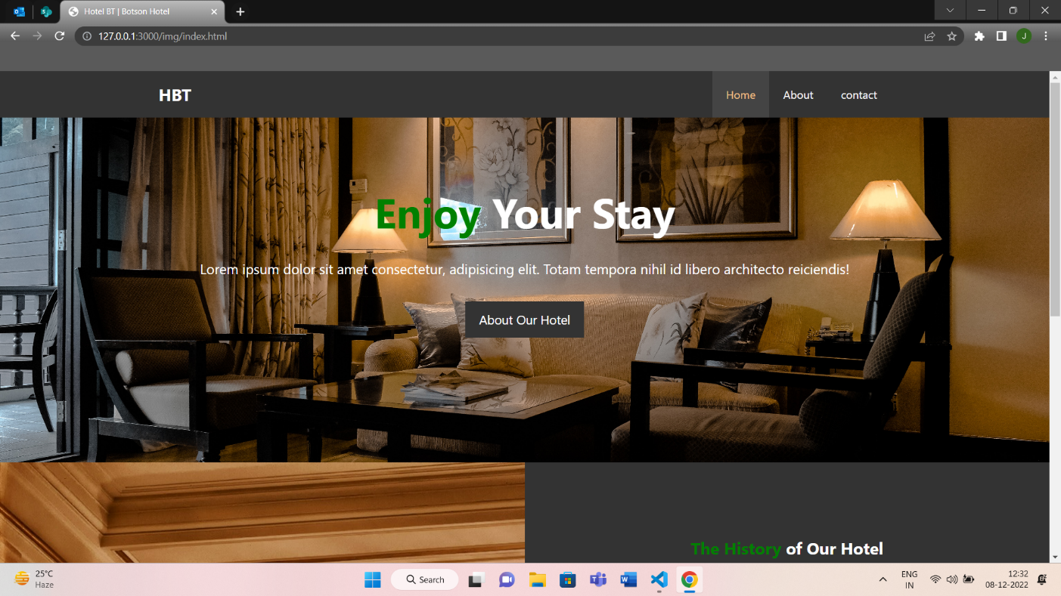

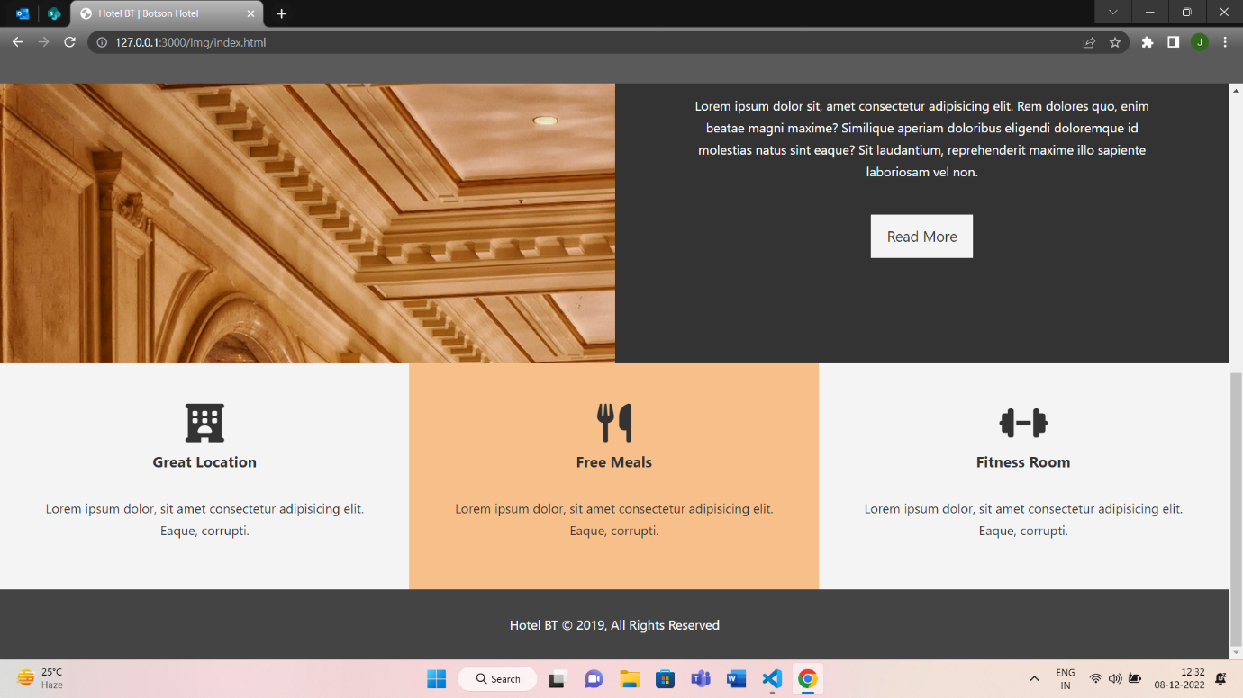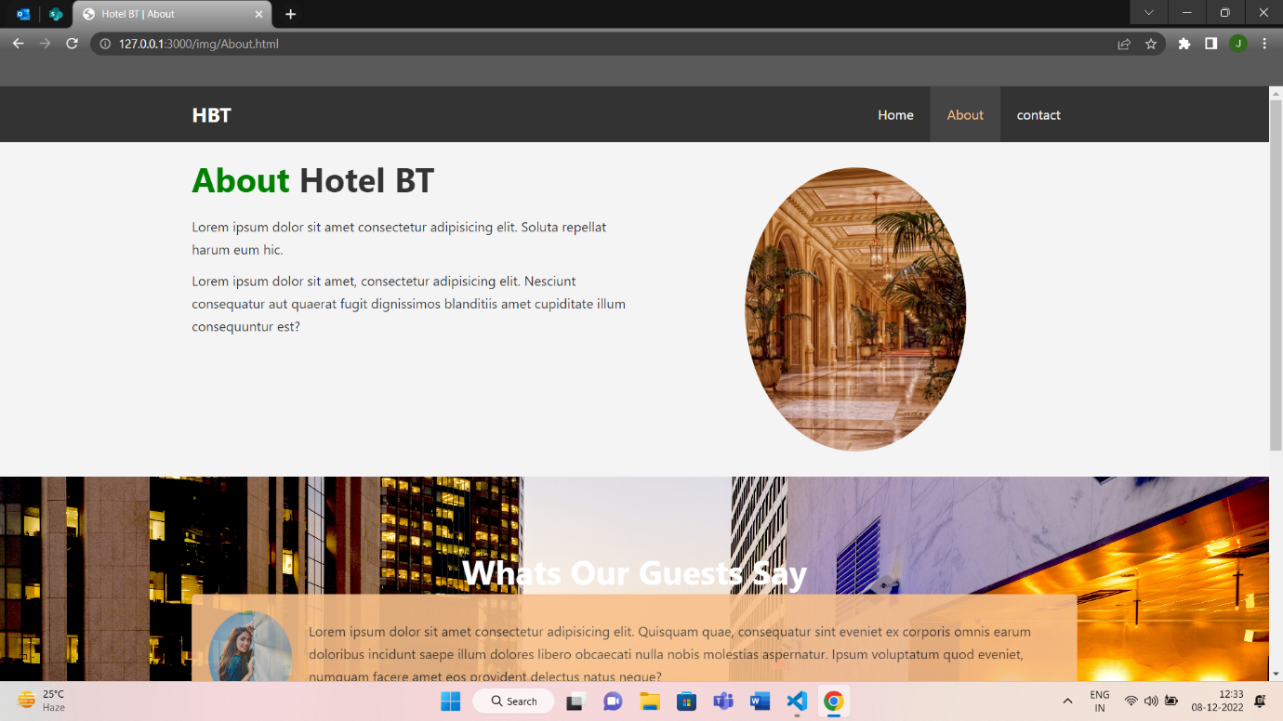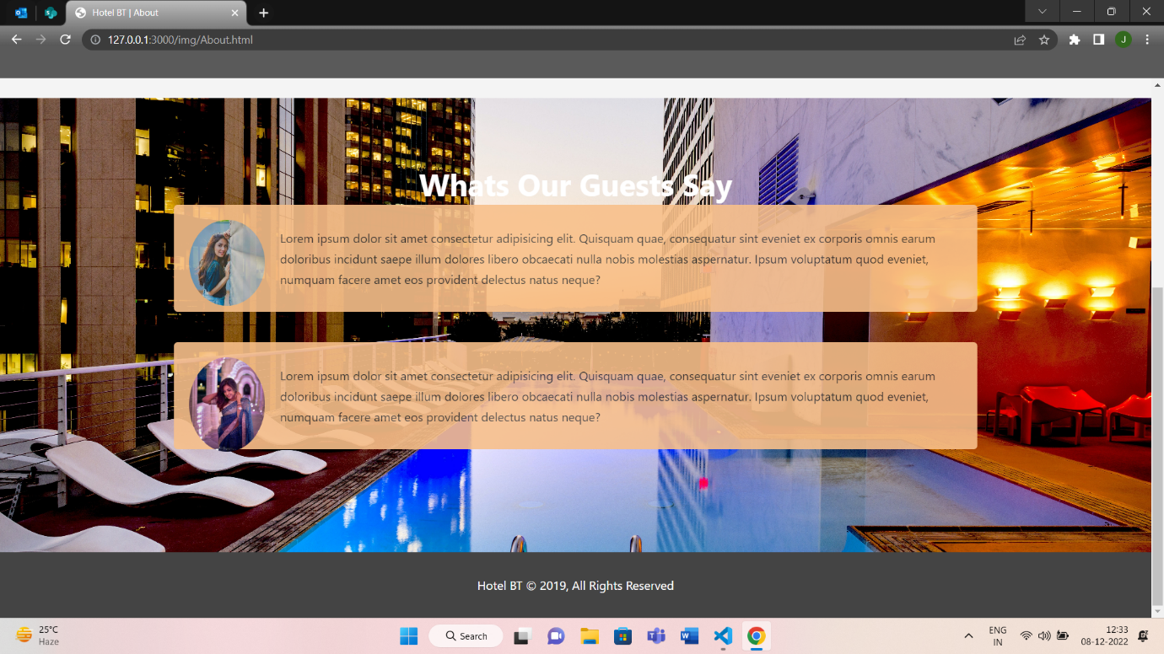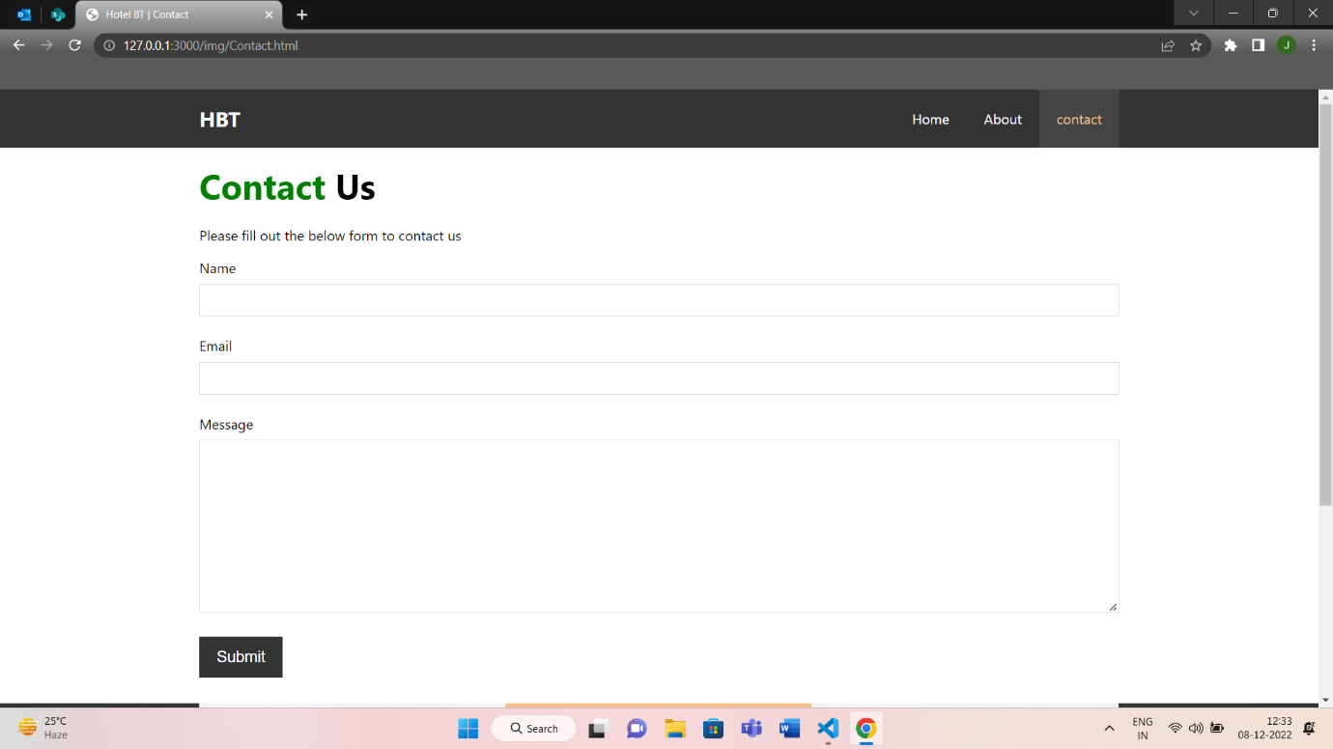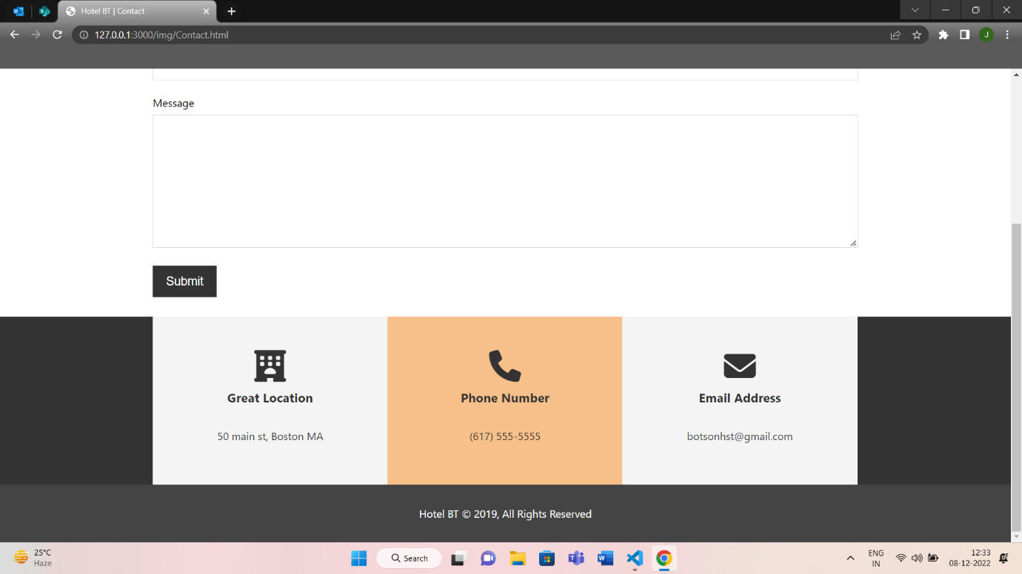

**Thank You**